# My Considerations: Process of finding fitting OD network

## Initial Try-Out: Different nets

* Training time
  + 5000, 10000, 20000 steps tested with my_faster_rcnn_resnet101_v1_1024
  + Difference between 5k & 10k
  + No big difference between 10k & 20k
    - For now let’s test with 10k
* Image resolution
  + Test similar net architecture with different resolution
  + Faster R-CNN ResNet101 V1 with 640x640 and 1024x1024 tested
    - 1024 can detect larger better; 1024 is more exact (+0,1 for [mAP@0.75](mailto:mAP@0.75))
* Architectures
  + Test different types of models
  + Faster R-CNN ResNet101 V1 1024 vs. my_ssd_resnet50_v1_fpn_1024
    - R-CNN +0,2 [mAP@0.5](mailto:mAP@0.5) and for large and small bubbles
  + Faster R-CNN ResNet101 V1 1024 vs. my_ssd_resnet101_v1_fpn_1024
  + Tried following architectures:
    - * Ssd_resnet50_v1_fpn_640
      * Ssd_resnet50_v1_fpn_1024
      * Ssd_resnet101_v1_fpn_1024
      * Faster_Rcnn_resnet50
      * Faster_Rcnn_resnet101_v1_640
      * Faster_Rcnn_resnet101_v1_1024
      * Faster_Rcnn_resnet152_v1_1024
      * Efficientdet_d1
      * Centernet_hg104_512
      * Centernet_hg104_1024
      * Centernet_resnet101_v1_fpn_512

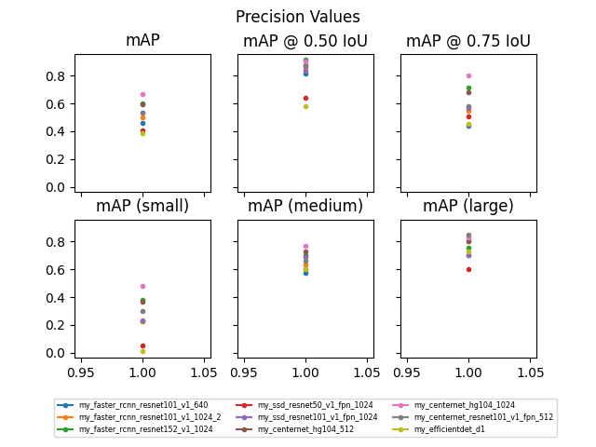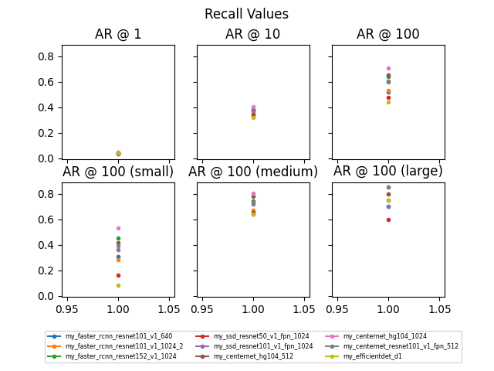

## Tuning of one net

### Ideas what to tune

* Vary images
  + Number of images
  + Number of bubbles
  + Try different degree of data augmentation
* Training time
  + Observe loss curve
  + Vary Epochs & Batch size

### Centernet_hg104_1024

* Images
  + 50/200?? imgs a 20 bubbles
    - ???
  + 200 imgs a 80 bubbles
    - my_centernet_hg104_1024_2 (num steps 20000 – 100 epochs)
    - my_centernet_hg104_1024_3 (num steps 10000 – 50 epochs)
  + 100 imgs a 80 bubbles
    - my_centernet_hg104_1024_3 (num steps 10000 – 100 epochs)
* Training time
  + 100 epochs
    - my_centernet_hg104_1024_4
    - my_centernet_hg104_1024_2
    - better precision at high IoU with more images (every image passed through net 100 times)
  + 50 epochs
    - my_centernet_hg104_1024_3
    - 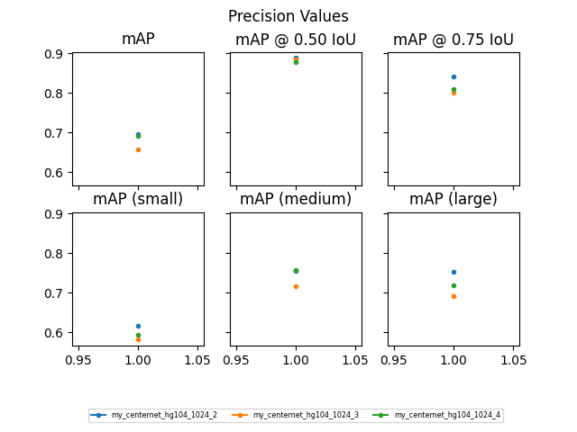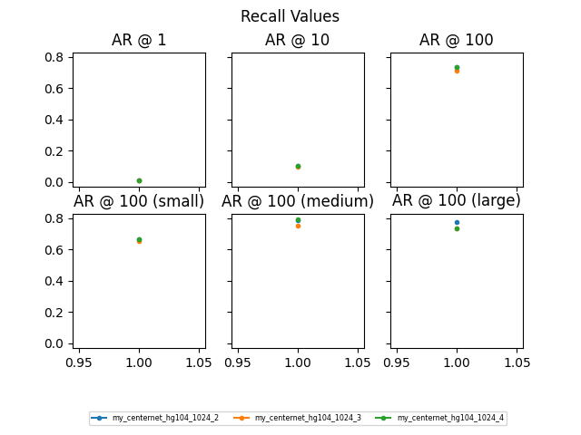0.5 x amount of images passed through net 2 x more times performs a little better

### Centernet_hg104_1024_2

* Tested on artificial images
  + Generated with code from Ivo
  + Estimated img dimension 20mm
  + Example: image 190 (80 bubbles)
    - Why annotation got 86 and not 80??
    - DETECTED ERROR: PICTURES FALSELY ANNOTATED: annotation created even for discarded bubble in case of overlap] --> *must* *retrain my_centernet_hg104_2 with corrected images 🡪 Done*
    - Distributions nicely overlay
    - 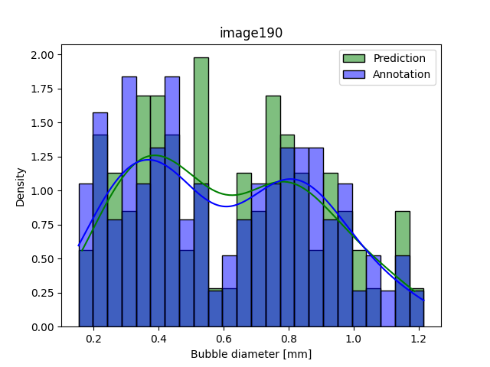Histogram bins range from min to max of both annotation and prediction

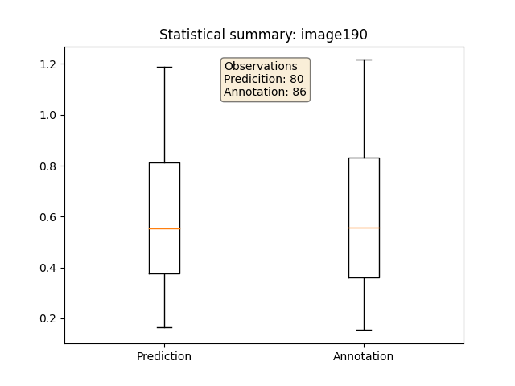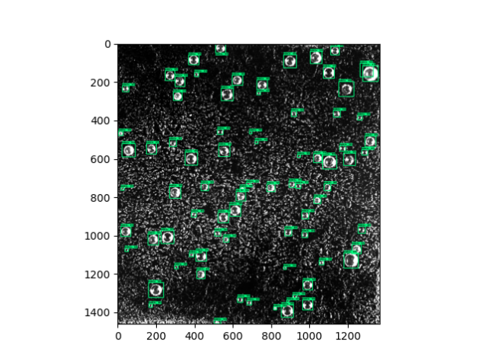

* Tested on image from Alessandro
  + Annotated with Labelimg
  + Not cropped!
  + Estimated img dimension 25mm
  + Example: sat016_t30_0001
    - Max number of predictions set to number of annotated bubbles – avoids too many detections BUT
    - Some bubbles detected easier on white background than small bubbles on black
    - Graphical user interface

      Description automatically generatedShift in bubble distribution towards larger radii

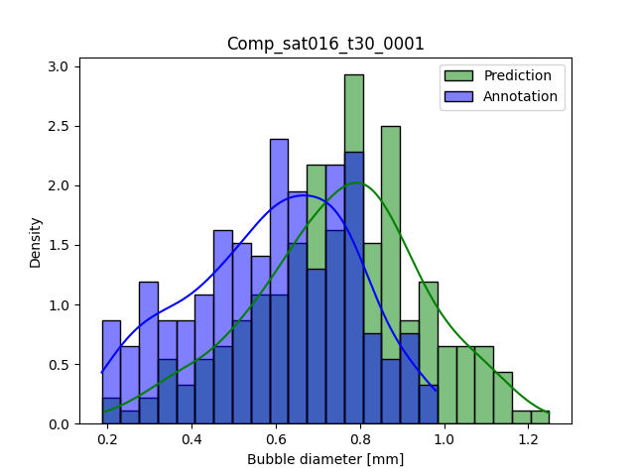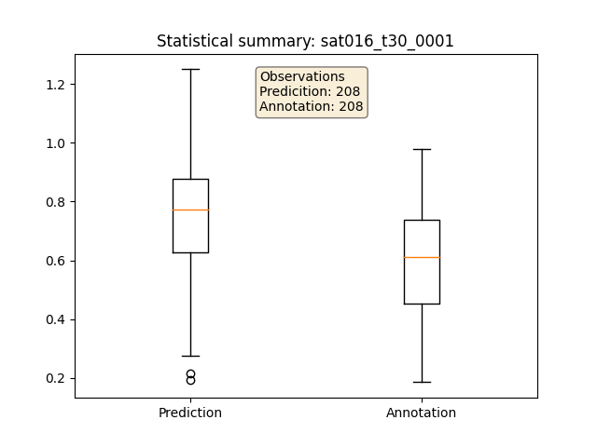

* Tested on image from Alessandro
  + Annotated with Labelimg
  + Tilted (aligned borders horizontally) and cropped
  + Estimated img dimension 20mm
  + Example: sat016_t30_0001_cropped
    - Max allowed detections: 300; detects exact same number of bubbles like in annotation
    - Predictions greater radii than annotation (inaccurately annotated?)
    - Cut-off bubbles on edge not annotated

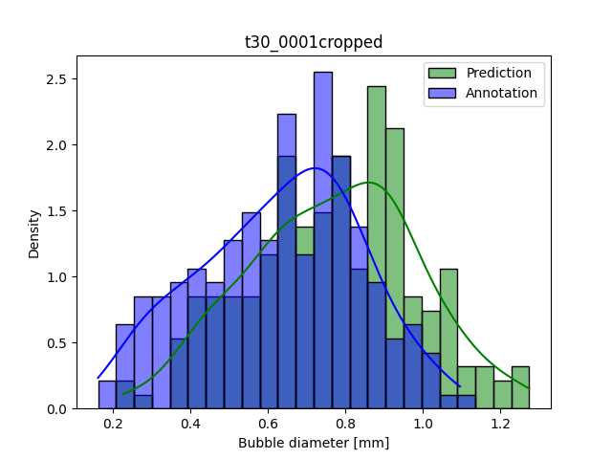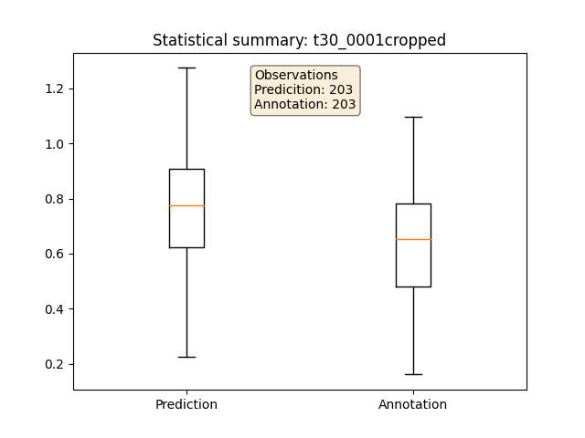

### retrained my_centernet_hg104_2 (with corrected image annotation wo bbox when bubble discarded) 🡪 my_centernet_hg104_5

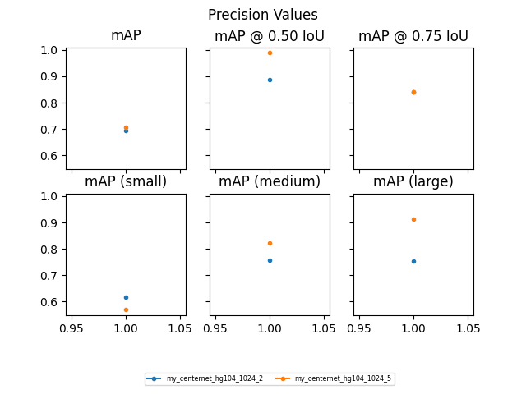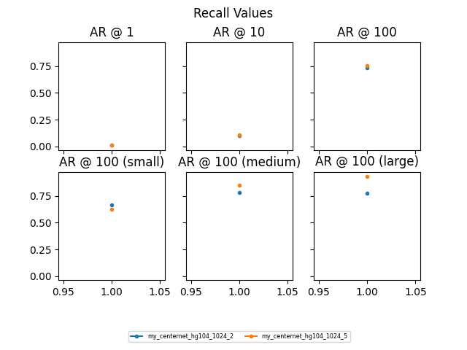

* Tested on artificial images
  + Estimated img dimension 20mm
  + Example: image 1 (80 bubbles)
    - Nice overlay of density curves
    - Missed a few bubbles (over whole range of bubble size)

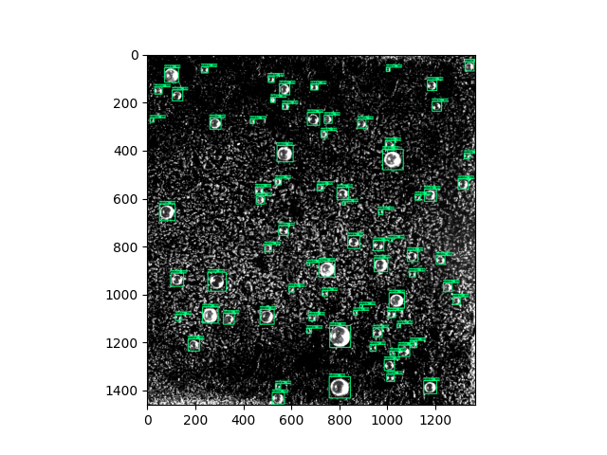

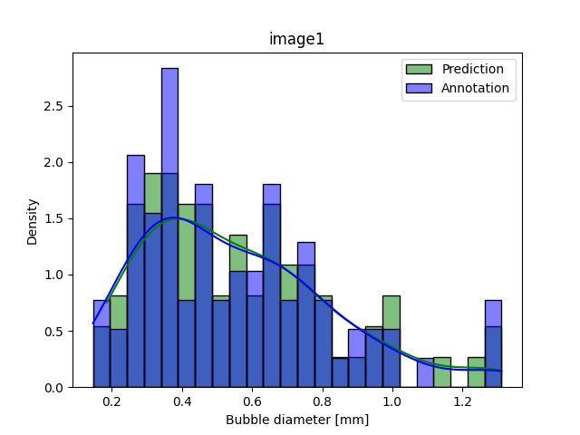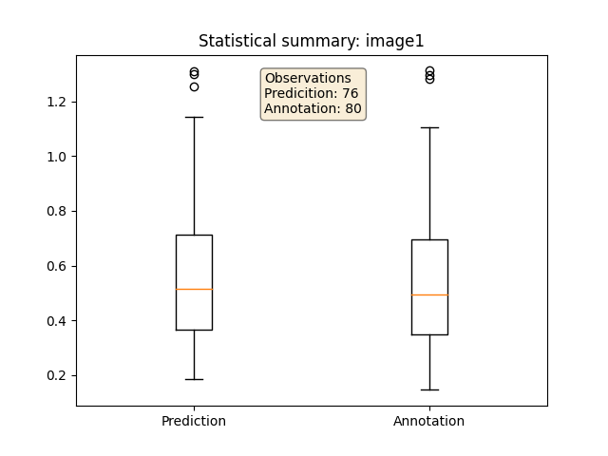

* Tested on image from Alessandro
  + Annotated with Labelimg
  + Not cropped!
  + Estimated img dimension 25mm
  + Example: sat016_t30_0001
    - Max. allowed detections: 208
    - Some bubbles detected easier on white background than small bubbles on black
    - Shift in density curve: predicts larger than annotated size
    - Shift in bubble distribution towards larger radii

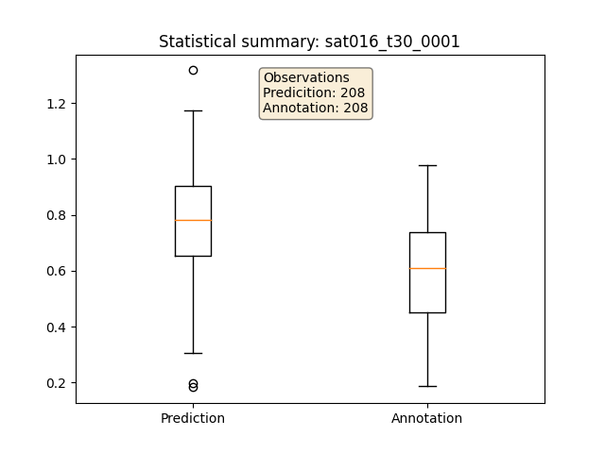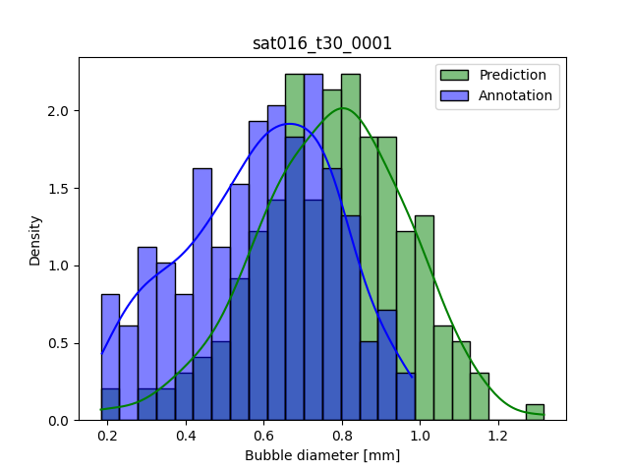

* Tested on image from Alessandro - cropped
  + Annotated with Labelimg
  + Tilted (aligned borders horizontally) and cropped
  + Estimated img dimension 20mm
  + Max. allowed detections: 300
  + Example: sat016_t30_0001_cropped
    - Still shift in distribution (slightly smaller)
    - Compare annotations: see if shift is due to error in optical measurement

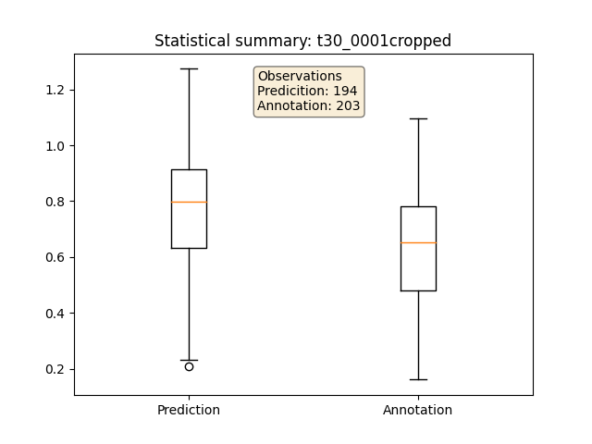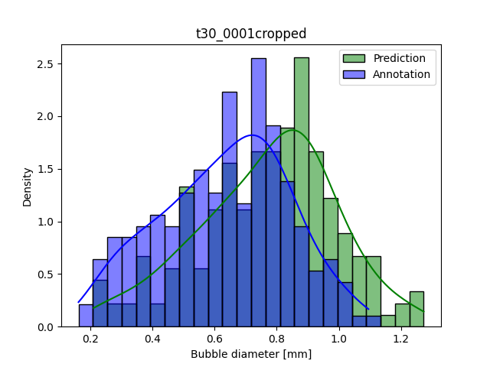

* Tested on image from Alessandro – cropped
  + Annotated with Labelimg by Ivo
  + Max. allowed detections: 300
  + Example: supersaturation_0.16_cropIR, t30_0001_cropped
    - Shift for larger bubble sizes slightly smaller than for annotation by JG

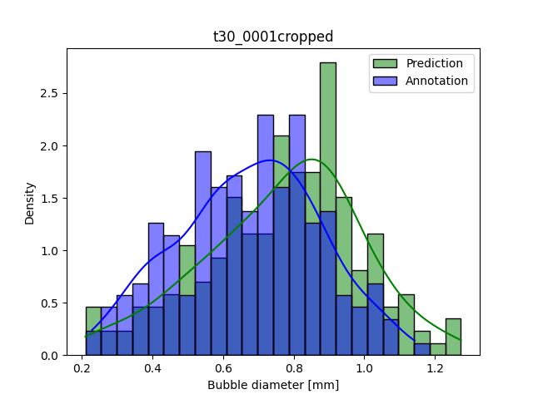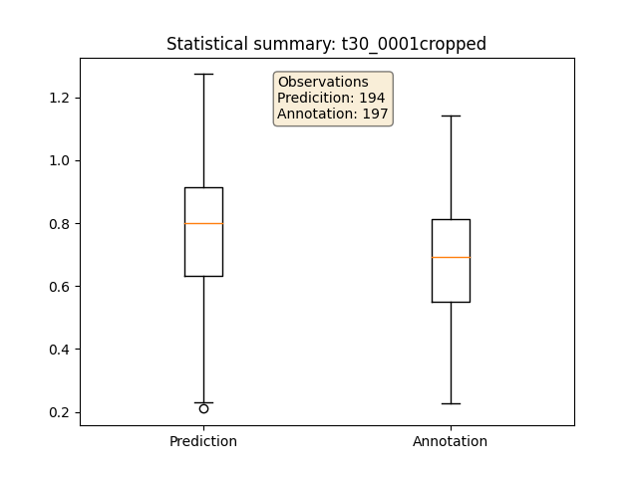

* Some bubbles appear to have headspace with the predicted bounding box
  + Analysis procedure done also with taking only the width of the bubble into account as the diameter
    - Not a satisfying approach
  + Visualized the annotated bounding boxes of artificial data (data that is used for training)
    - For some bubbles: annotation box too large (see example)
    - Creation of artificial images + annotation needs to be corrected 🡪 done

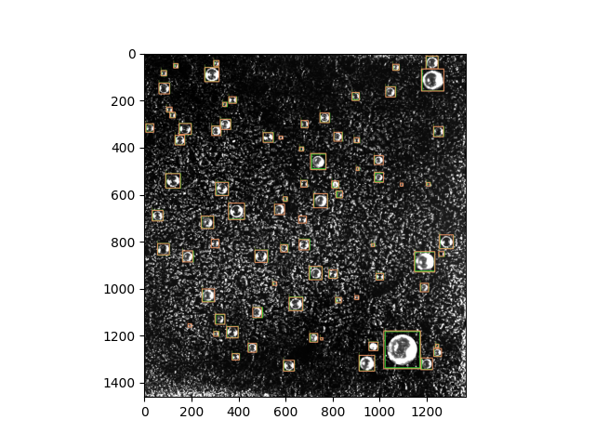

* In create_training_images.py
  + Sigma_scaling_fraction, highlight_bubbles, blur_mask, sigma_rotate_degree set to 0 or False
  + Not possible to locate evident differences visually; Still headspace for some bubbles?
    - Test with those images and watch histogram if shift appears/is different for different datasets
    - Maybe due to bubble instances?
    - Examine bubble instances
    - Why is there blur mask? Not Blur mask and blur bubble?
* Tested (Model trained with augmented images [Net 5])
  + NoAug
    - No “bubble (data) augmentation”; bubble instances not modified
    - annotations seem smaller than prediction
  + Blurmask
    - Only “blurmask”=True
    - annotations seem smaller than prediction
  + Rotate10
    - Only rotation up to 10 degrees enabled
    - Annotations **do not** seem smaller than prediction 🡪 coincidence? Does not make sense that rotation is cause for smaller annotations, because annotations are created after the rotation
    - See f.i. image6_Annot: bubble instances seem to contain background?

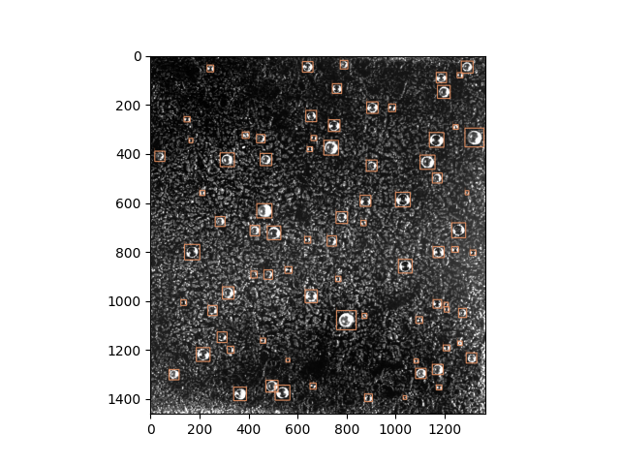

* + Scaling0.2
    - Only scaling of 0.2 enabled
    - annotations seem smaller than prediction

## Modify training images

* See if annotation by JG makes any difference compared to annotation from IR
* New annotation with labelme
* creation of mask with maskGen.py
  + virtual environment ‘tfod’
  + in visualization: unique color for each bubble
  + Mask: Unique int values for pixels of respective bubble; background==0
* Extract_and_save.py
  + Creation of pickle file containing bubble instances
* Create new training images with create_training_images.py

Questions

* Annotation: cut white edge? 🡪 for now yes; annotate as big as I estimate true bubble
  + - See results when model trained with those imgs

### Further trained my_centernet_hg104_5 (with newly annotated bubble masks) 🡪 my_centernet_hg104_5_v2

- New images created with own annotations (JGmask)

- based on about 50 annotated bubble instances within image t15_0001.tif

- net5 retrained with +20 artificial images created with JGmask

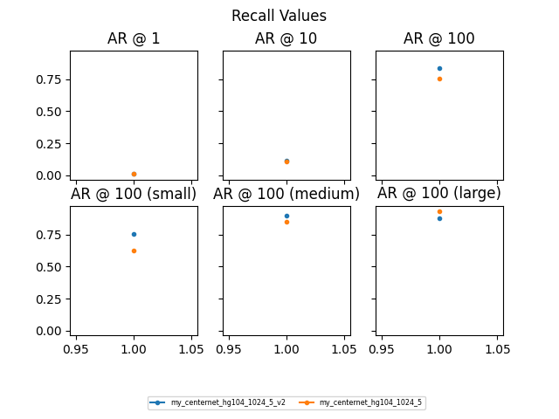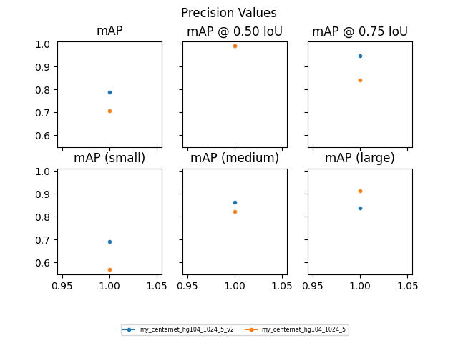

* Comparison Net5 & Net5v2: tested on 20 artificial test images, created with masks from Ivo
  + V2 can clearly detect better for higher IoUs and small bubbles
  + Overall mAP higher for v2
  + Smaller bubbles
    - Recall better with v2
    - V2 less false negatives (does not miss as many bubbles as v1)
  + Large bubbles
    - mAP for v2 lower
      * V2 fits BB better around bubbles?
      * V2 has more false positives?
      * Does mAP @ 0.75 IoU says anything about the amount of bubbles that were detected? Could v1 detect more bubbles, just not as precisely and therefore have a lower mAP?
    - Recall slightly worse with v2
    - V2 misses a few big bubbles
* Should be tested again when struggle with space of annotation around the bubble is fixed 🡪 see what influence that has on Evaluation Metrics
* Tested on artificial images, created with JGmask
  + Estimated img dimension 20mm
  + Example: image 4 (80 bubbles)
    - Why do bubble annotations still leave so much space around bubble, even though it was tightly annotated? 🡪 maybe because of rotation
    - 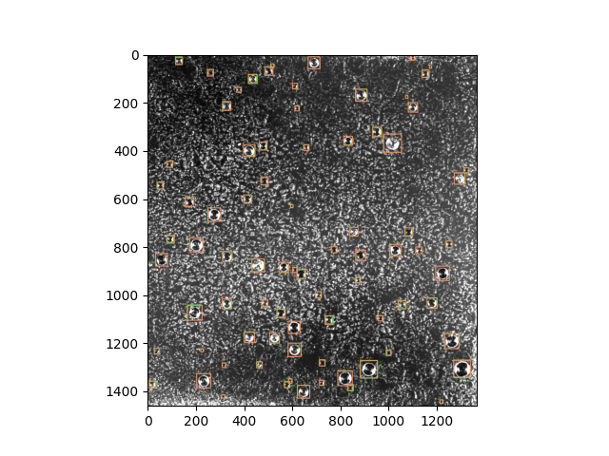Further investigation into create_training_images.py

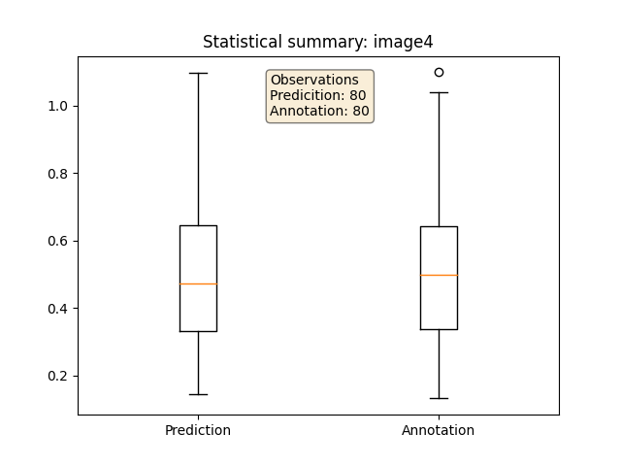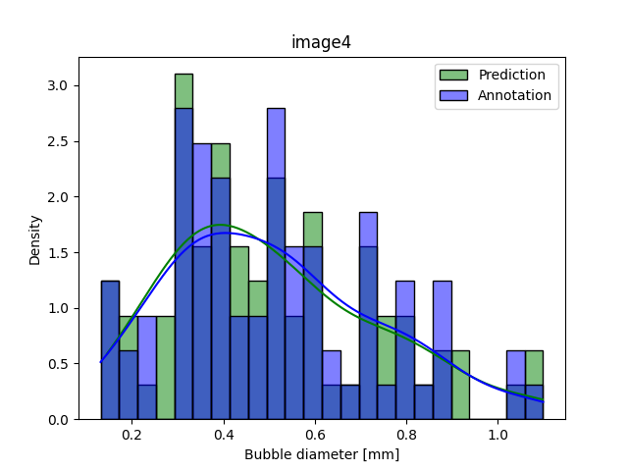

* Tested on image from Alessandro – cropped, annotated by IR
  + Estimated img dimension 20mm
  + Max. allowed detections: 300
  + Threshold: 0.5
  + Example: sat016_t30_0001_cropped
    - 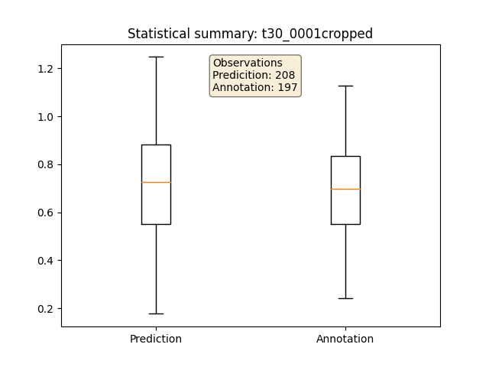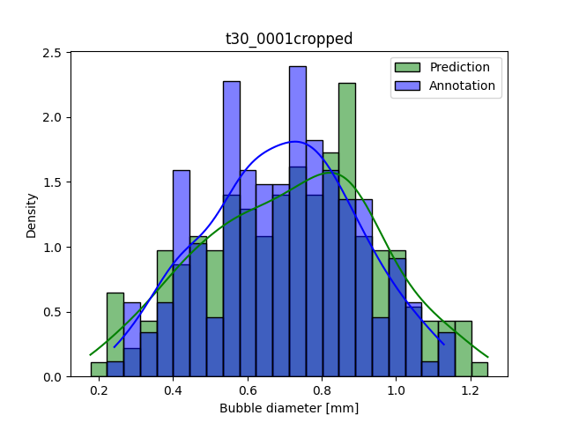A picture containing qr code

      Description automatically generatedShift in distribution smaller
    - Net5_v2 predicts a bit tighter around bubble than net5
    - Outlook: How to deal with cropped bubbles?

## Create training images: Examine space around bubbles

* Might come from rotation
* Img.rotate(degree,expand=True) 🡪 expansion of output image in order to host the whole rotated image
* Since bubbles are annotated as circles (not ellipses): rotation should not crop the bubble
  + - Test out artificial images without expansion within rotation function 🡪 output_10_100_space_analysis
      * Inspect visually 🡪 promising
      * Create new bubble masks with more bubble instances, annotated with LabelMe by JG (for more examples / generalization)

Created new bubble masks: bubbles_4img_maskJG.pickle

File 0: Original: ./org/t02_0001.tif Mask: ./mask/t02_0001-labels.tif

Found 48 instances on mask

File 1: Original: ./org/t10_9ms_0004.tif Mask: ./mask/t10_9ms_0004-labels.tif

Found 53 instances on mask

File 2: Original: ./org/t15_0001.tif Mask: ./mask/t15_0001-labels.tif

Found 51 instances on mask

File 3: Original: ./org/t30_9ms_0001.tif Mask: ./mask/t30_9ms_0001-labels.tif

Found 57 instances on mask

* + - Created new training images with these masks (bubbles_4img_maskJG.pickle) 🡪 output_200_80_4imgmaskJG
      * Not sure about white and blurred bubbles 🡪 should be ok; similar to IR bubble instances and that worked as well
    - Created new training images without rotation expansion with masks from Ivo 🡪 output_200_80_maskIR
    - Created new training images without rotation expansion with masks from Ivo AND JG
    - Train network 5 with new images 🡪 see if BB fit tighter
    - Train centernet_hg104 (original) with new images (masks from JG) 🡪 see if BB fit tighter

### Further trained my_centernet_hg104_5 (with newly annotated bubble masks) 🡪 my_centernet_hg104_5_v3

- net5 trained with +90 artificial images from new mask (without expansion in rotation)

* Tested on 20 artificial images from maskJG
  + 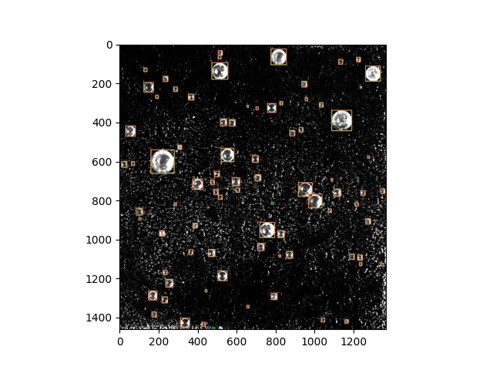Threshold 0.5

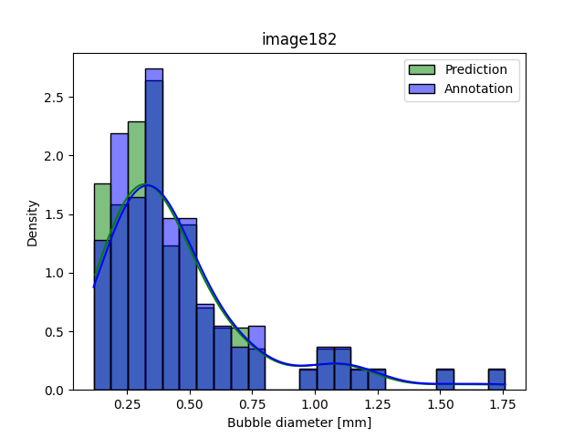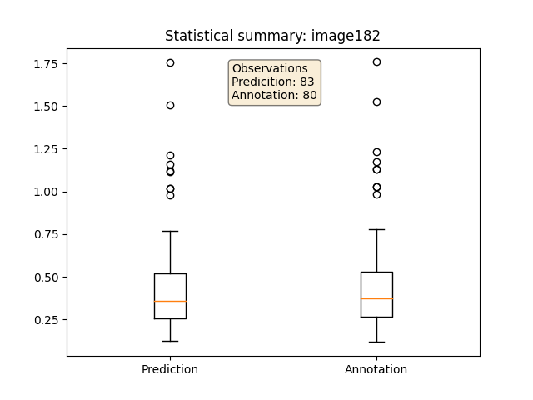

* Tested on real images, cropped, annotated by IR
  + Threshold 0.5
  + 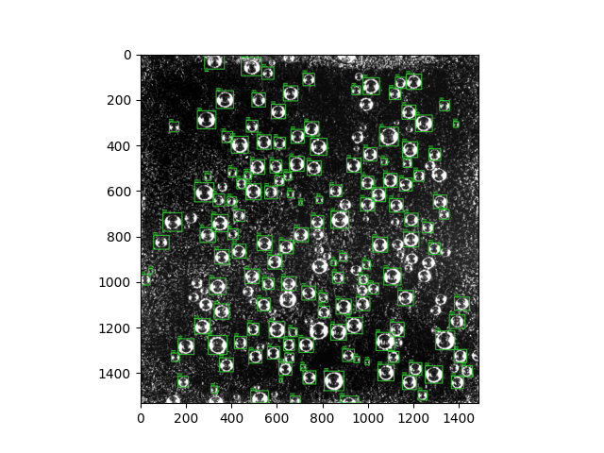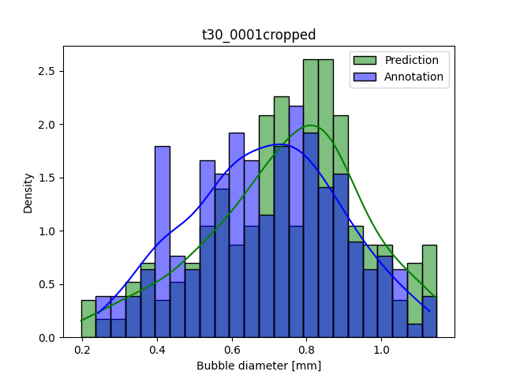Misses a few bubbles

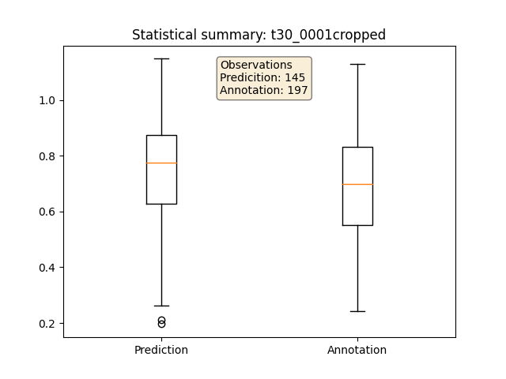

* Tested on real images, cropped, annotated by IR
  + 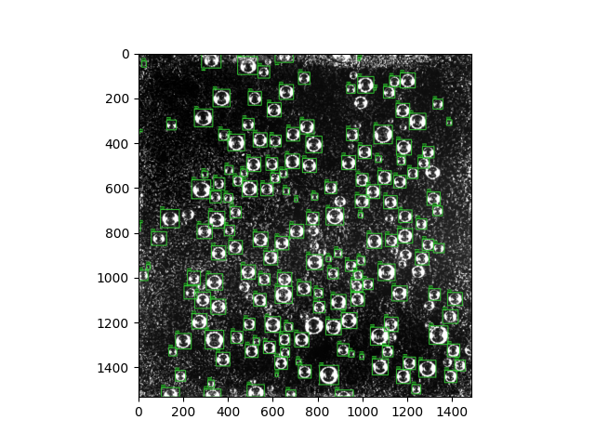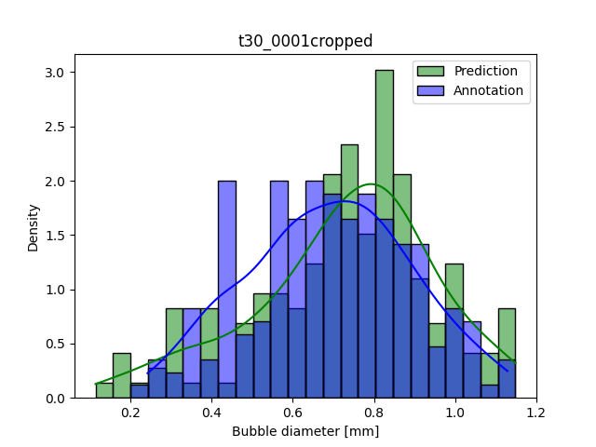Threshold 0.3

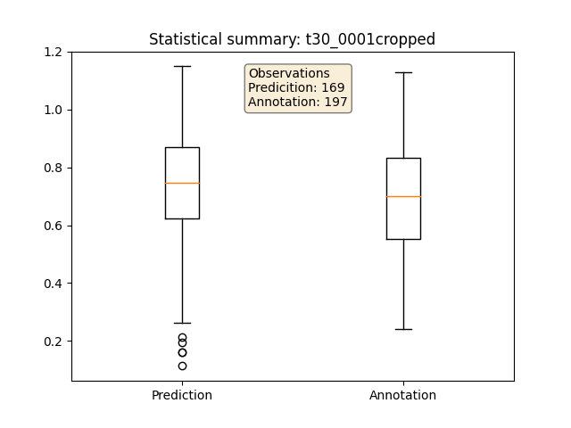

### my_centernet_hg104_6 (with newly annotated bubble masksJG)

- completely trained with maskJG

* Tested on 20 artificial images from maskJG
  + Threshold 0.5
  + 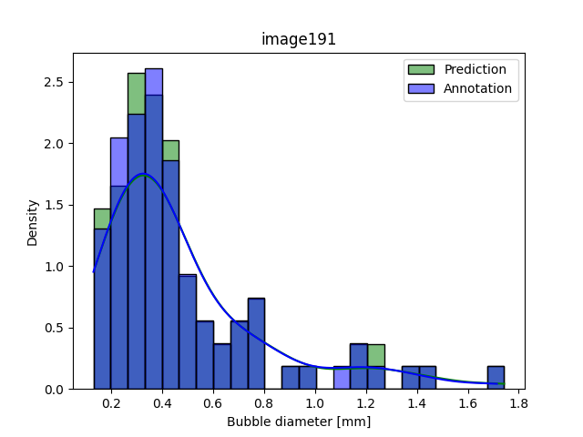N_Prediction between 77 and 87

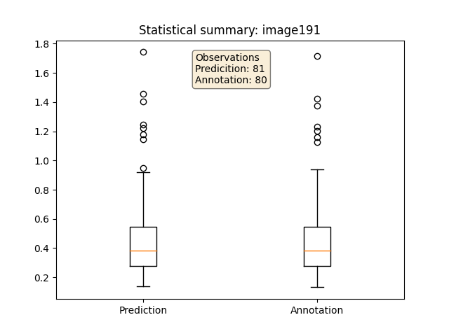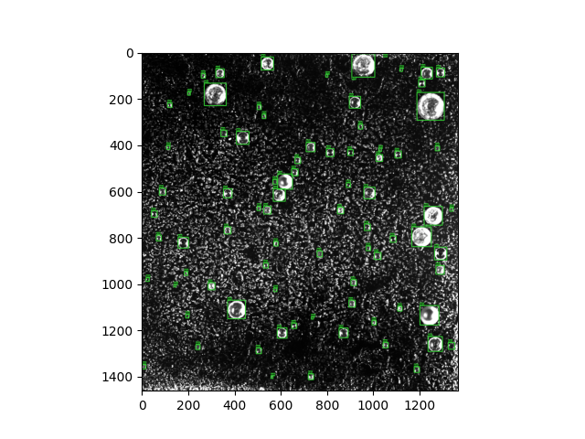

* Tested on real, cropped, annot IR
  + Threshold 0.5
  + Clearly misses a few bubbles
  + Detects smaller bubbles than annotated
  + 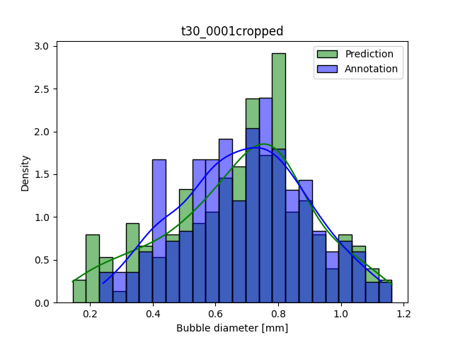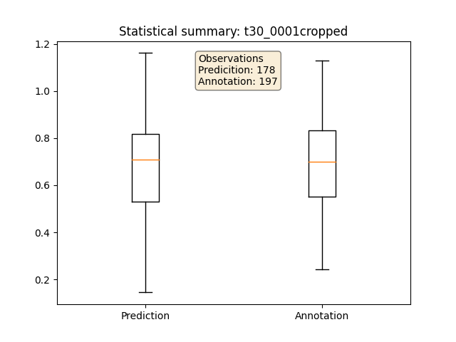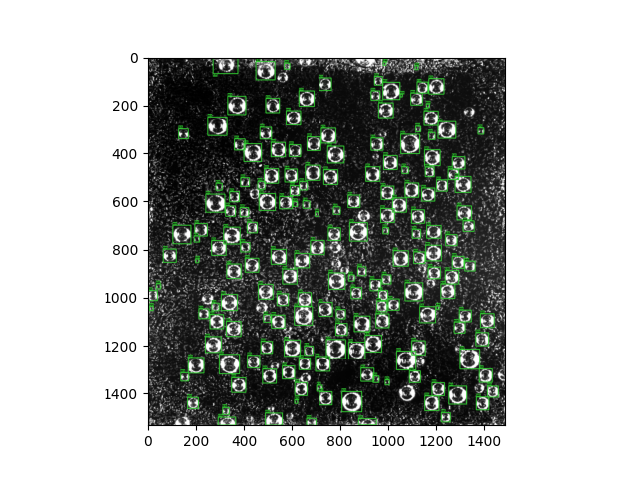Detects cut-off bubbles
* Tested on real, cropped, annot IR
  + Threshold 0.3
  + Detects smaller bubbles than annotated
  + Detects cut-off bubbles

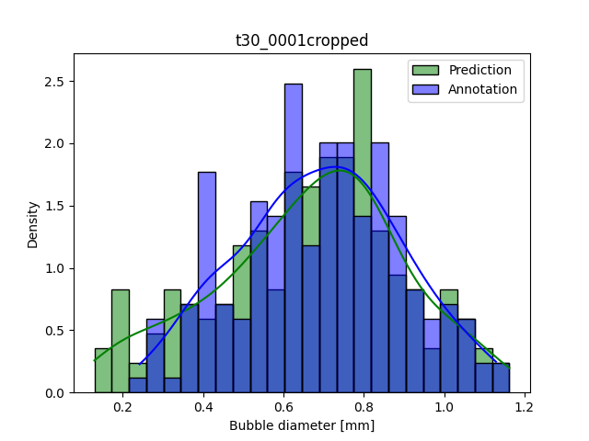

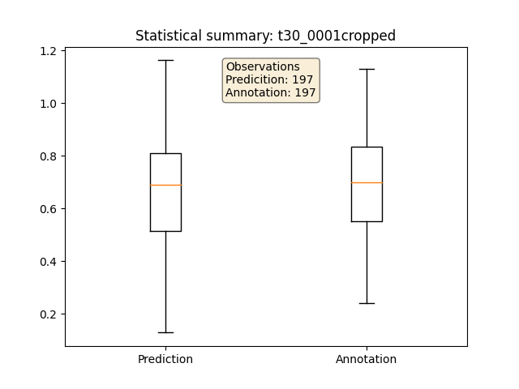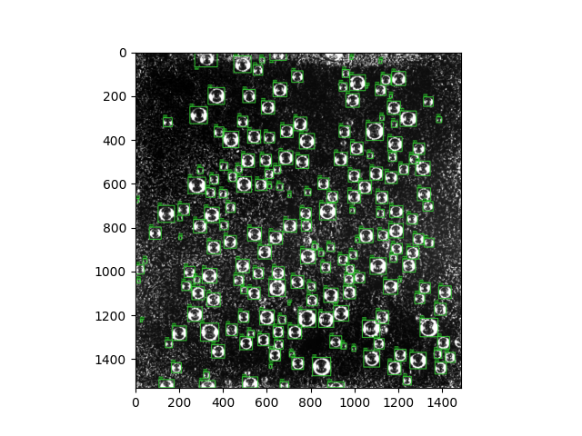

### Comparison net 5, 5_v3, 6

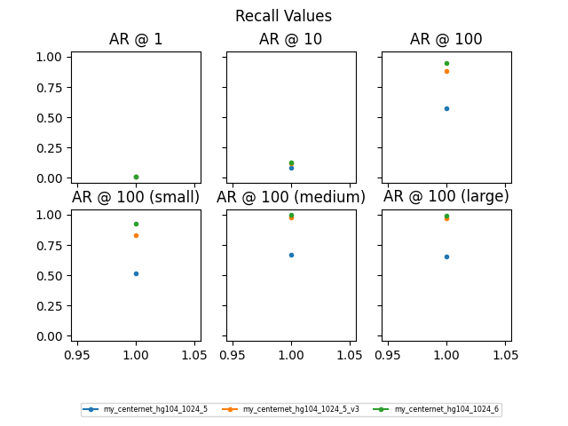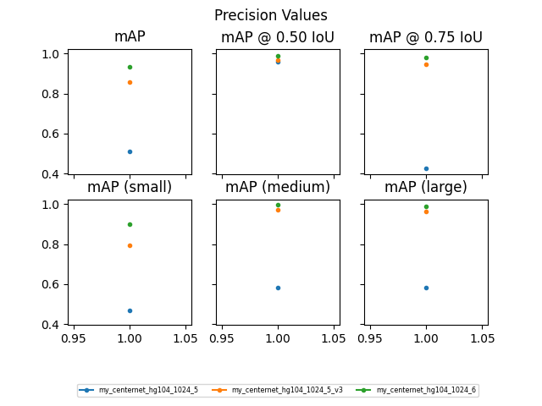- tested on 20 artificial images with maskJG

* 5_v3 and 6 very similar
* 6 slightly better for smaller bubbles
* Conclusion: (Re-) Training with new annotations without rotation expansion clearly boosted the performance
* Calculations of Prec/Rec not possible for n_bubbles>100

### my_centernet_hg104_7 (with newly annotated bubble masksJG&IR)

* Tested on artificial images, based on masksJG&IR
  + 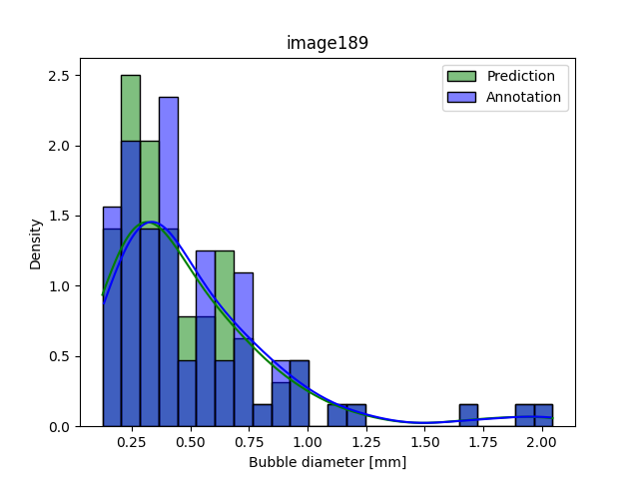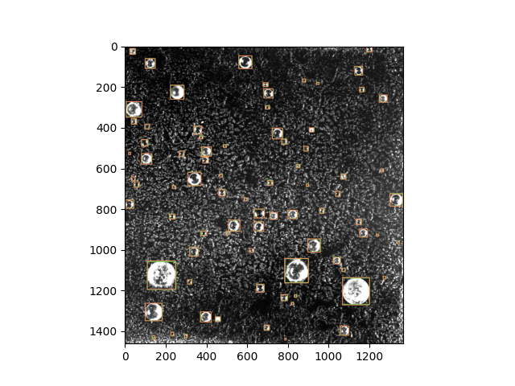Threshold 0.5

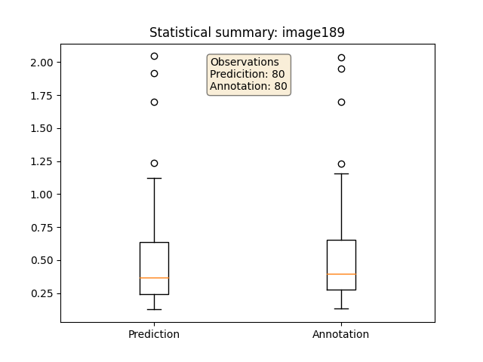

* Tested on real images, cropped, annotated by IR
  + 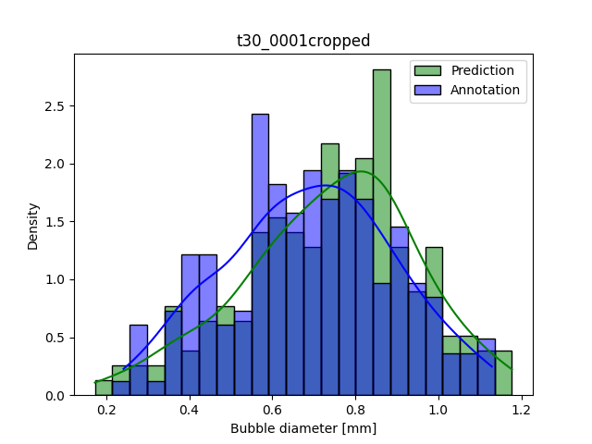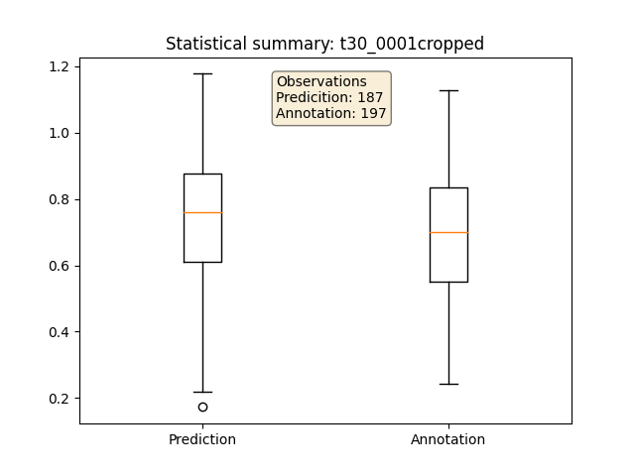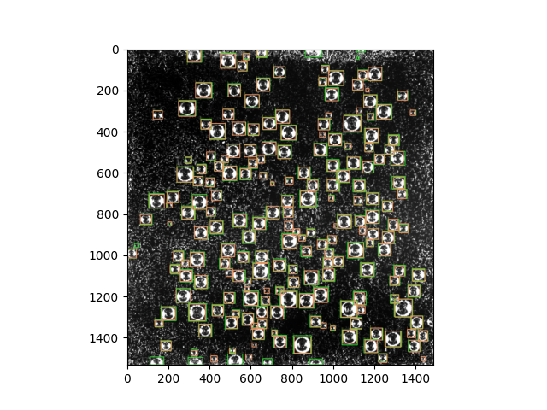Threshold 0.5
* Tested on real images, cropped, annotated by IR
  + 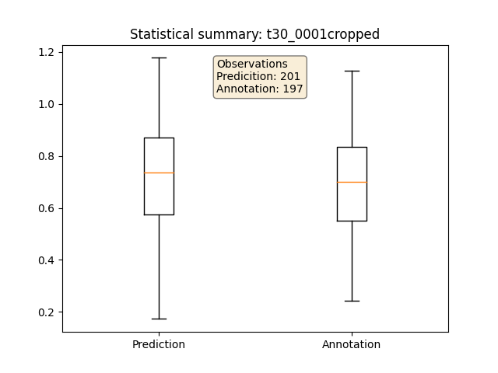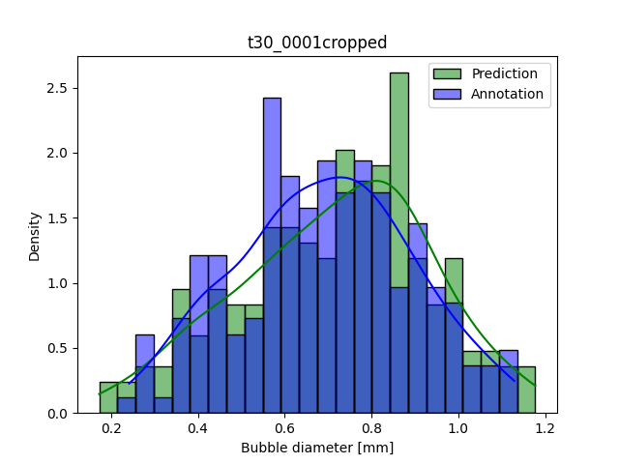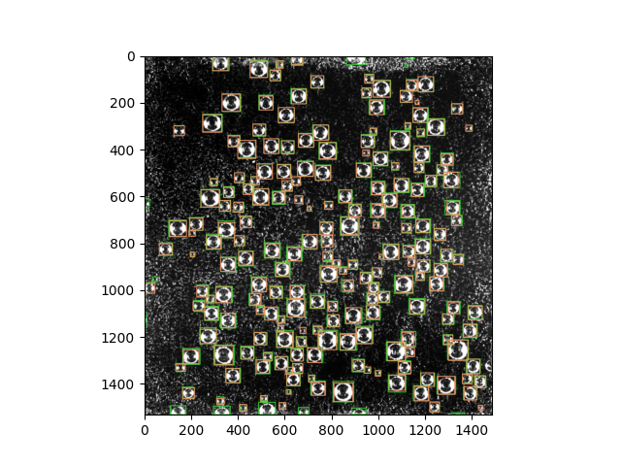Threshold 0.3

### Comparison Net 5, 5_v3, 6, 7

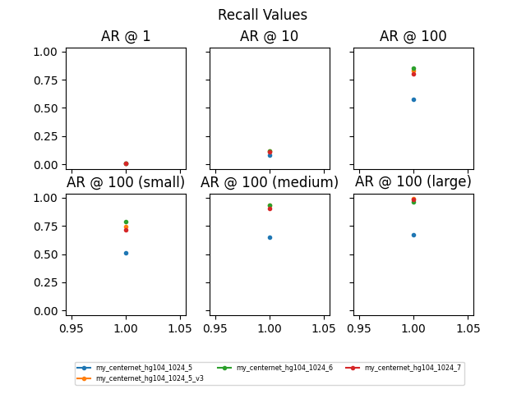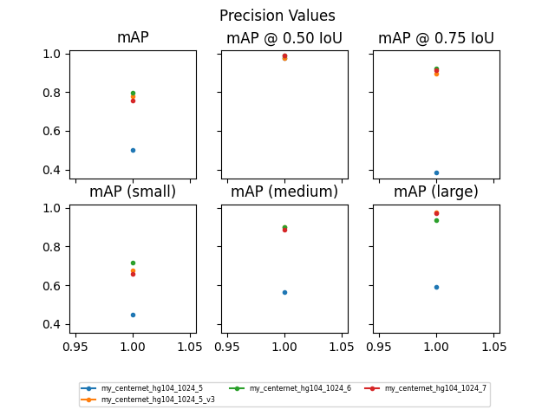Tested on 20 artificial images generated with maskJGIR

* Only Net 7 has been trained on similar images (maskJGIR); others trained with old masks or only maskJG
  + Nevertheless performance of other nets good on this data
  + Usage of maskJGIR did not have a big impact compared to training with maskJG
* Nets trained with new masks without rotation expansion is a success
  + Difference to net 5 that was trained with expansion in bubble sequence rotation
* When observing bubble size distributions
  + Net 7 contains a slight shift: predicted bubble diameters larger than annot
  + Net 6: Nice overlay of pred and annot probability densities

### New modifications on code

* Drawing small objects (<32^2 pixels, defined by COCO) in different color (Models_SeparateTest.py)
* Exclude detections from result that have a distance < x pixels from img boundary 🡪 avoid detections of partial bubbles (Models_SeparateTest.py)
* New way of calculating evaluation metrics and plot the precision recall curves (also for whole datasets consisting of multiple images)
  + Create COCO json file of annotations and results (Models_SeparateTest.py)
  + Use COCO json files for calculating Metrics and plot PR-Curve (Models_EvalCOCO.py)
  + Slight differences in metric values when calculated right after Training or with 3. Eval new test & with Models_SeparateTest.py / Models_EvalCOCO.py (even when taking the detections without the partial exclusion)
* For now metrics can be only calculated for max 100 detections!
  + Did not find out how to set “maxDets” withing metric calculation
  + For artificial images no problem because can be set with < 100 bubbles
  + For real images: maybe test precision and recall on smaller section of annotated image? 🡪 only on images with few bubbles
  + Detections and Data Analysis possible for larger amount of bubbles 🡪 insofar not affected / no problem

### my_centernet_hg104_7_v2 (trained with bigger bubble instances)

* Net 7 detected new images, taken by JG poorly, especially big bubbles
  + - Need to modify images that they look like Alessandros
    - Train network further with big bubble instances
* Comparison to net 7
  + V2 detected more bubbles overall
  + Average diameter very similar, v2 sometimes slightly higher
  + V2 more detections within bubbles: detects part of bubble as one bubble
    - Visually no real improvement
      * Sometimes more (big) bubbles detected
      * But also apparent errors

### my_centernet_hg104_8 (trained from scratch with new artificial images based on Nikon annotations)